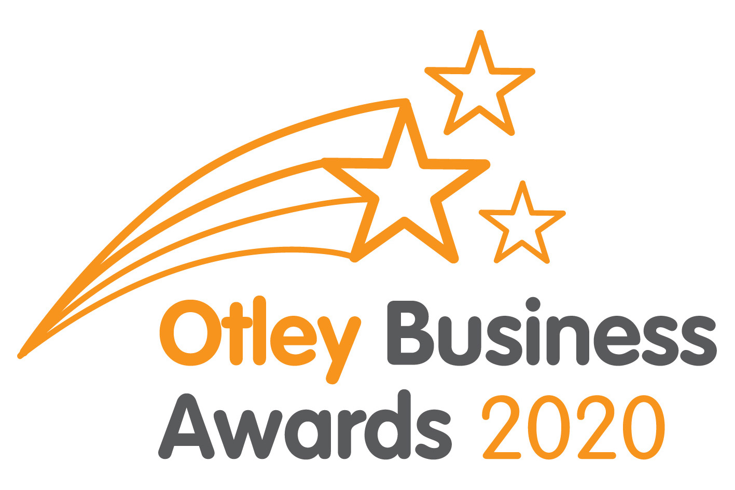
BUSINESS INFORMATION PACK
Welcome to the launch of the 2020 Otley Business Awards.
The Awards showcase the best of YOU, our Otley businesses, as voted by YOUR customers and clients.
Organised by Otley Chamber of Trade, the Otley Business Awards 2020 is in its 6th year and continues to go from strength to strength. Without the support of our kind Sponsors this event would not be possible, so special thanks go to our main sponsors, Otley BID and Otley Town Council, our media partner Stray FM, our Awards Committee of volunteers and finally, last by certainly not least, the Otley businesses who have kindly sponsored our 16 Award Categories:
 | Apollo 3D  Newstead & Walker Solicitors  Otley Town Council  Otley Chamber of Trade  Arundel Travel  Cranbourne Accountancy  Rest Assured Homecare  Otley BID  Hollins Crowe Storr LLP Accountants  Aura Jewellery  The Yorkshire Wordwright | Sponsors the Newcomer  Sponsors the Best Micro Business  Sponsors the Best Large Business  Sponsors the Best Service Sector  Sponsors the Best Retail  Sponsors the Best Food & Drink  Sponsors the Best Cafe  Sponsors the Good Service Award  Sponsors the Best Community Award  Sponsors the Best Apprentice/Trainee  Sponsors the Best Employer Award
 | Otley in Bloom | Sponsors the Best Kerb Appeal
 | Basil Lettings | Sponsors the Outstanding Contribution by an Employee Award
 | Haycock & Jay Associates | Sponsors the Environmental Award
 | Alpha Male Barbers  Ivy House Botanicals & Well-being | Sponsors Best Pub  Sponsors the Lifetime Achievement Award
To help you understand how your business can get involved and be nominated, we have enclosed the following documents:
- A small number of Nomination Forms
- The list of Award Categories
- Examples of Mystery Shopper Judging Criteria – Best Retail & Best Service Sector

How do I enter my business?
The majority of the awards nominations are solely based on your customer’s reviews, we recommend that you ask your customers to nominate you.
If you’re a customer facing business you could hold a number of Nomination Forms in your shop or office. Please offer them to your customers for them to complete and return to the address as shown on the form.
If you sell your products & services direct to businesses you could email your customers and send them a link to the online Nomination Form available on the Chamber of Trade’s website www.otleychamber.co.uk.
However, this year we have some NEW award categories where BUSINESSES or their EMPLOYEES can nominate themselves for:
- Best Employer Award
- Outstanding Contribution by an Employee Award
- Best Kerb Appeal
- Environmental Award
- Best Apprentice/Trainee
Also NEW for this year - please let us know if you have won any other INDUSTRY AWARDS and these will be acknowledged at the awards ceremony – email admin@otleychamber.co.uk.
What happens if I run out of Nomination Forms?
If you require further copies of the Nomination Forms, these can be collected in person from the Otley Core in Orchard Gate (open Monday to Friday) or downloaded/completed online via the Chamber website www.otleychamber.co.uk.
How do I make sure I’m nominated in the correct category?
Help your customers by suggesting to them which category you would like to be nominated in. An explanation of all the categories can be found within each Nomination Form.
When are nominations open?
Nominations open tomorrow - Wednesday 13th NOVEMBER and will close on FRIDAY 10TH JANUARY 2020.
Marketing
This is a great opportunity to promote your business by spreading the word about this fabulous annual celebration of the Otley business community. As a result of promoting the event, you can help your customers by advising them how they can nominate you and where to find the Nomination Forms. Stray FM will be promoting the Awards throughout the nomination period. They will also be covering the Awards Ceremony next March, as will our local press supporter, the Wharfedale Observer.
Otley Chamber of Trade will be promoting the event over the next 5 months. So please get involved and let’s spread the word about how friendly, supportive & fantastic Otley businesses are. You can:
- LIKE Otley Chamber of Trade’s Facebook page @otleychamber and SHARE our posts
- FOLLOW Otley Chamber of Trade’s Twitter page @OtleyChamber and RETWEET our posts
- REMEMBER to use the hashtag #OBA20 on your social media so that we can find your posts and share them.
How are the winners decided?
Once the nomination period has closed your business will be visited or called on by a mystery shopper. They will assess your business and service against a range of criteria (an example of which is included within this Information Pack), along with the comments your customers write when nominating you.
Depending on the nature of your business a range of factors such as websites and online reviews will be assessed too. So that the number of nominations collected does not have any influence on the overall outcome, you could still win if you only receive one completed Nomination Form!
Need help?
As an Otley business we’d love you get involved and hope this has explained the process, although if you would like to know more please email admin@otleychamber.co.uk.
Our Guest Motivational Speaker
We are also very excited to announce that STEPHANIE MOON, Chef Consultant for All Things Food, has kindly agreed to be our GUEST MOTIVATIONAL SPEAKER for the evening. Stephanie was born and raised in North Yorkshire, a farmer’s daughter who trained at Craven College then went on to work at one of London’s top hotels ‘The Dorchester’, then returned to her Yorkshire roots working as Head Chef at Wood Hall, Coniston Hall and Rudding Park to name but a few. You may recognise her from TV too as she has competed in The Great British Menu and compered at our own Otley Food Festival cookery tent. She also has a programme on Stray FM, our local radio station in the Wharfe Valley.
The all important Awards Ceremony
Please ensure if you are going to take part that you are able to attend the Awards Ceremony on the evening of Friday 20th March 2020 or at least send a representative. You wouldn’t want to win and not be there to celebrate your success in front of over 100 Otley business owners!
So all that remains to say is good luck everyone, let’s celebrate Otley’s best businesses!
With our very best wishes,
The Otley Business Awards Committee

