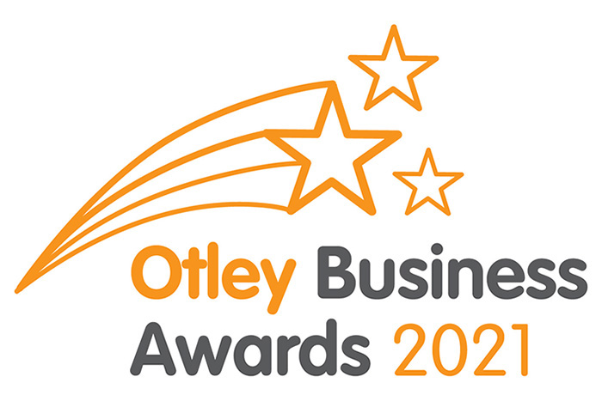

Otley Business Awards 2021 – Information for businesses
Welcome to the virtual launch of the Otley Business Awards 2021, we would love your business to get involved and as you can imagine we have had to adapt our processes this year. Here is what you need to know;
What category can I get my customers to nominate my business in?
Best Newcomer – Nominate any business which has been open since January 2020
Best Service Sector – Nominate any business that sells services to other businesses or the public. E.g. accountants, banks, estate agents, cleaners, care service providers, hair & beauty, solicitors, financial services etc
Best Retail – Nominate any business which sells good to the public
Best Eatery –Nominate any restaurant, café, takeaway or dining pub.
Best Pub/Bar – Nominate your favourite public house/bar
Good Service Award – Nominate any business that has demonstrated continued exceptional service over and above your expectations
Covid 19 Community Award – nominate any business that has contributed to supporting the Otley community during the Covid19 pandemic
Lifetime Achievement – Nominate and Otley business person/s who have made outstanding contributions to Otley’s business community over a significant period of time.

What category can I nominate my own business in?
Best Apprentice/Trainee – Employers Only – nominate your apprentice/trainee who has contributed to your business
Environmental Award – Nominate your business if it is working to improve its environmental footprint.
This year every single business has been nominated in the Best Kerb Appeal category and our friends at Otley in Bloom have been keeping tabs on exterior paint work, cleaning, branding and planters during the whole year and will decide the winner of this category.
How are nominations made?
This year all nominations must be made online by your customers visiting www.otleychamber.co.uk. You might want to suggest which category they should nominate you in. Paper nomination forms are not available and will not be accepted.
When can nominations be made?
The nomination form will be live on the website from Tuesday 17th November 2020 until Sunday 10th January 2021.
How can I encourage my customers to nominate my business?
This is a great opportunity to promote your business and it’s part in the fabulous Otley business community.
Attached to this email is a poster you can print out and put in your window or use social media to tell your customers how to nominate by going to www.otleychamber.co.uk
Otley Chamber of Trade will be promoting the event over the next 5 months. So please get involved and let’s spread the word about how friendly, supportive & fantastic Otley businesses are. You can:
- LIKE Otley Chamber of Trade’s Facebook page @otleychamber and SHARE our posts
- FOLLOW Otley Chamber of Trade’s Twitter page @OtleyChamber and RETWEET our posts
- REMEMBER to use the hashtag #OBA21 on your social media so that we can find your posts and share them.
How are the winners decided?
Once the nomination period has closed each category will go through a shortlisting process where the following criteria will be assessed;
- Social media
- Website
- Branding and kerb appeal
- Community involvement
- Any available reviews
Due to ongoing uncertainty about visiting businesses we are unable to commit to every business being “mystery shopped” this year, so the information your customers put on the nomination form will be our primary source of information. In some categories shortlisted businesses may be “mystery shopped”
Need help?
As an Otley business we’d love you get involved and hope this has explained the process, we will be available at the Otley Chamber of Trade meeting held via Zoom on Tuesday 17th November at 6pm. Here are the details to join this meeting
Join Zoom Meeting
https://us02web.zoom.us/j/89980515260...
Meeting ID: 899 8051 5260
Passcode: 121940
If you would like to know more please email oba@otleychamber.co.uk.

The all important Awards Ceremony
Due to ongoing uncertainty about Covid19 restrictions we have been unable to plan the usual Awards Ceremony, but the winners will be notified on Friday 19th March 2021 via an online event which we will tell you more about nearer the time. The winning businesses can expect certificates, awards, a big up on social media and hopefully some press coverage too.

So all that remains to say is good luck everyone, let’s celebrate Otley’s fabulous business community!

With our very best wishes,

The Otley Business Awards Committee
a.k.a Katie Burnett – Courtyard Planters
Helen Wilkinson – Dowgill House Bed and Breakfast
Simon Raybould – Print Crew

