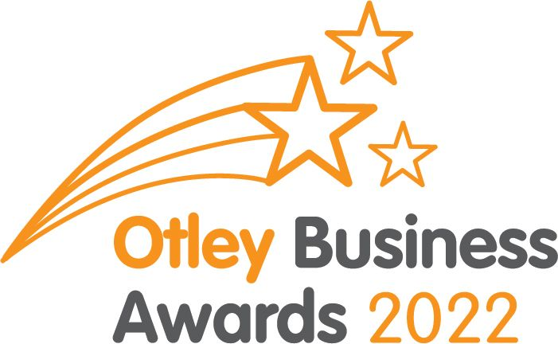
BUSINESS INFORMATION PACK
Welcome to the launch of the 2022 Otley Business Awards
The Awards showcase the best of YOU, our Otley businesses, as voted by YOUR customers and clients
Organised by Otley Chamber of Trade, the Otley Business Awards 2022 is in its 8th year and continues to go from strength to strength. Special thanks go to our main sponsors Otley BID and Otley Town Council and our committee of volunteers as without their support this event would not be possible
How do I enter my business?
The Otley Business Award categories for 2022 are:
- Best Newcomer – ask your customers to nominate you if you are a new business which has opened since January 2021
- Best Service Sector – ask your customers to nominate your business if it sells services to other businesses or the public
- Best Retail – ask your customers to nominate your business if you sell goods to the public
- Best Eatery – ask your customers to nominate your restaurant, café, coffee shop, takeaway or dinning pub
- Best Pub/Bar – ask your customers to nominate your public house or bar
- Good Service Award – customers can nominate any business that has demonstrated continued exceptional service over and above their expectations
- Community Award – customers can nominate any business that has contributed to supporting the Otley community during 2021/22
- Best Apprentice/Trainee – nominate your outstanding apprentice or trainee who has made a difference to your business
- Environmental Award – nominate your own business if it is working to improve its environmental footprint
- Best Kerb Appeal – Do you take pride in the appearance of your business? It’s not who’s got the grandest building it’s what you do with it to make Otley look its best. Nominate yourself
- Outstanding Contribution to the Otley Business Community – formerly the Lifetime Achievement Award, nominate a fellow business person who has been a support to your business and/or the wider Otley business community over the years

The majority of the categories rely on customers to nominate a business so we recommend that you ask your customers and clients to nominate you and give their reasons why using the online nomination form on the Otley Chamber of Trade website www.otleychamber.co.uk
(We no longer supply or use paper nomination forms for environmental reasons and to keep everything confidential)

How do I make sure I’m nominated in the correct category?
Help your customers by suggesting to them which category you would like to be nominated in. Any nominations made obviously in the wrong category will be moved to the appropriate category and still considered

When are nominations open?
Nominations open on Wednesday 14th November 2021 and will close on Friday 14th January 2022

Marketing
This is a great opportunity to promote your business. To help promote the awards you can help your customers by advising them how they can nominate you and where. Spread the word about this fabulous annual celebration of the Otley business community to your customers and other businesses
Otley Chamber of Trade will be promoting the event over the next few months so please get involved and let’s spread the word about how friendly, supportive and fantastic Otley businesses are. You can:
- Facebook - LIKE Otley Chamber of Trade’s page @otleychamber and SHARE our posts. Remember to use the hashtag #OBA22 on your social media so that we can find your posts and share them
- You can also share the link to the Otley Chamber of Trade website on your social media accounts and via email to direct your customers and clients to the online Nomination Form www.otleychamber.co.uk
- Talk – tell your customers and other businesses you talk to

How are the winners decided?
Once the nomination period has closed your business will be visited by an independent mystery shopper. This will be someone from another town and maybe another part of the country, who isn’t familiar with Otley
They will assess your business and service against a range of criteria, along with the comments your customers write when nominating you
Depending on the nature of your business a range of factors such as websites, social media and online reviews will be assessed too. The number of nominations collected does not have any influence on the overall outcome, you only need one completed Nomination Form to get on the starting line!

Need help?
We’d love all Otley businesses to get involved and hope this has explained the process, although if you would like to know more please email info@otleychamber.co.uk.

The Awards Ceremony
The glittering ceremony, staged in Otley’s largest public space, the magnificent Otley Parish Church, starts with a welcome drink, food and a guest speaker before the awarding of the trophies and a photo for use in local newspapers and the Otley Business Awards ‘Hall of Fame’ on the Chamber website
We are very excited to announce that Stephanie Moon, Chef Consultant for All Things Food, has kindly agreed to be our Guest Motivational Speaker this year
Stephanie was born and raised in North Yorkshire, a farmer’s daughter who trained at Craven College then went on to work at The Dorchester, one of London’s top hotels, before returning to her Yorkshire roots as Head Chef at Wood Hall, Coniston Hall and Rudding Park. You may recognise her from TV too as she has competed in The Great British Menu and compered at our own Otley Food Festival cookery tent
If you are going to take part please ensure that you are able to attend the Awards Ceremony on the evening of Friday 18th March 2022 or at least send a representative. You wouldn’t want to win and not be there to celebrate your success in front of countless other Otley businesses!
So all that remains to say is good luck everyone, let’s celebrate Otley’s businesses!

With our very best wishes,
Katie, Pippa & Helen
The Otley Business Awards Committee

